Low Level Design (Booking confirm module)

Project Code | Team1
Project Name | Airline Reservation System

Prepared/Modified by | Role | Date of Preparation
Sanjay | Sr. Software Engineer | 7/11/2017
Reviewed by | Role | Date of Review
Vaishali Srivastava | Training Manager | 14/11/2017
Approved by | Role | Date of Approval
Vishal Mali | Training Manager | 15/11/2017
Circulation List | himanshu.a.sinha@capgemini.com ,  sanjay.sanjay@capgemini.com ,  prashansa.rani@capgemini.com ,  intkhab.ahmed@capgemini.com | Version Number of the template:1.0
Version Number | 1.0

Table of Contents

1. Description Of The Unit 3
2. References 4
3. Dependencies / Assumptions 5
4. Class Diagrams 6
5. Design Components 8
5.1 List Of UI Components 8
5.2 List Of Design Classes 8
6. Re-Usable Routines/Components 9
7. Messages 10
8. Configuration Files 11
9. Crud Matrix Table 12
10. Data Mapping Matrix 13
11. Action Flow Matrix 14
12. Stored Procedures 15
13. Program Specification / Pseudo Code 16
REVISION HISTORY OF THE WORK PRODUCT 17

Description Of The Unit

The Booking Confirm module allows the customer of the application to book a ticket. After the customer has booked the ticket in the application, the booking data is inserted into database and displayed on the confirmation page.

The customer is also given the choice to cancel the ticket upon which the ticket is cancelled from the booking information and the customer is navigated to the home page.

References

Reference | Description
Repository reference | https://github.com/intkhabahmed/ARS
Class Diagram | /Project Documents/Design Documents/HLD/Class Diagrams
URS | /Project Documents/Requirements/Case Study/Group-1-Airline Reservation System.doc
UTP | /Project Documents/Test Plan/UTP/Test Cases/Booking Confirm/UTP_BookingConfirmModule.xls
DB Design | /Project Documents/Design Documents/HLD/DB Design/AirlineReservationSystem _GROUP_DBDESIGN.xls

Dependencies / Assumptions

Dependencies:
The booking confirm module is dependent on flight search module wherein the booking is done for a flight searched.

Assumptions:
Flights exists for which booking has to be carried out.

Class Diagrams

Class Diagram

Design Components

List Of UI Components
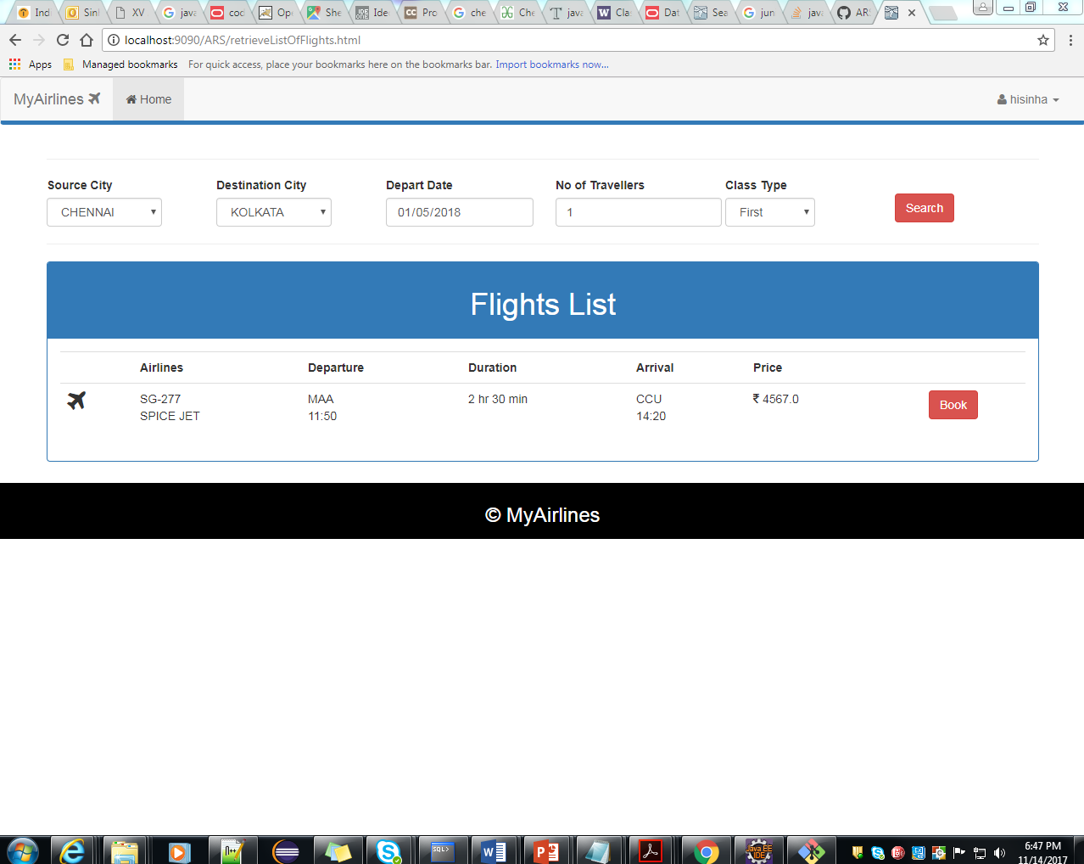

5.2 List Of Design Classes

Sr. No. | LLD Name | Class Name | Method Name | Method Description
1 | Booking Confirm Module | BookingInformation | Appropriate getters and setters methods | Getters retrieve the property values and setters set the property values
2 | Booking Confirm Module | Flight | Appropriate getters and setters methods | Getters retrieve the property values and setters set the property values
2 | Booking Confirm Module | AirlineController | public String bookFlight (@ModelAttribute(ARSConstants.BOOKING) BookingInformation bookingInformation, Model model, HttpSession session)  public String confirmBooking (@ModelAttribute(ARSConstants.BOOKING) BookingInformation bookingInformation, Model model) | Sets the model attribute and  Retrieves a list of flights from a particular source to destination and date, and sends it to the confirm booking page, if book option is clicked.  Calls the confirmBooking method in AirlineServiceImpl  Goes to the confirm booking page and asks for the credit card credentials. The user is also given an option to cancel his/her booking
3 | Booking Confirm Module | AirlineServiceImpl | public BookingInformation confirmBooking(BookingInformation booking) | Calls confirmBooking() of AirlineDAOImpl class and returns the result to AirlineController.
4 | Booking Confirm Module | AirlineDAOImpl | public BookingInformation confirmBooking(BookingInformation booking) | Inserts the booking details into the database and returns the result to AirlineServiceImpl

Re-Usable Routines/Components

Re-Usable Routines/Components

- CSS files
- JavaScript files
- DataAccessException class
- Database properties files
- Logger properties files

Messages

#. | Type | Message Text
1 | Error | Please fill out this field.
2 | Error | Card number should be of 10 digits

Configuration Files

File Name | Path | Description
Web.xml | /Development/source/ARS/WebContent/WEB-INF | To configure the bean properties.
ARSServlet-config.xml | /Development/source/ARS/WebContent/WEB-INF/config | To configure the request mapping and view resolver.
log4j.properties | /Development/source/ARS/resources | To configure the logger.
jpaContext.xml | /Development/source/ARS/resources | To datasource connection and autowired the bean.

Crud Matrix Table

# | Table Name | Create | Read | Update | Delete
1. | Flight | N | Y | N | N
2. | BookingInformation | Y | N | N | N

Data Mapping Matrix

Sr. No. | Screen Label | Field Source | Field Type | Data Type | Max Length | Data Flow | Mandatory
1 | Credit/Debit Card Details | NA | Label | NA | NA | UI | NA
2 | creditCardInfo | Bookinginformation.creditCardInfo | textArea | Varchar2 | 10 | UI → D | Yes
3 | Pay | N/A | Button | N/A | N/A | UI | N/A

Legend
D → UI (Database to User Interface)
UI → D (User Interface to Database)
UI (User Interface Only)

Action Flow Matrix

Sr. No. | Action | Description | Process
1 | On click of confirm button in place order page | The order details are inserted into the database. | The customer clicks on the confirm button in the place order page and gets redirected to the page which displays the order details of the customer.
2 | On click of cancel button in place order page | The order details are not added into the database. | The customer is navigated to the home page and the order is canceled.

Stored Procedures

# | Stored Procedure Name  (with Description) | Input/Out Parameters | Type | Size
1. | NA | NA | NA | NA

Program Specification / Pseudo Code

<ACTION :CONFIRM_CLICK >

Pseudo Code:
- Client Side Scripting:
None

- Server Side Scripting:

BEGIN
Call processPlaceOrder(@ModelAttribute("Order") ,BindingResult result,Model model) in Controller class in Presentation Layer
BEGIN
Call insertOrderDetails(List<Product> cartList, double total, String userId)in EshopBOImpl class in Service Layer
BEGIN
Call insertOrderDetails(List<Product> cartList, double total, String userId) in EshopDAOImpl class in Data Access Layer
BEGIN
Create query for insert records into order table
Return Integer value.
END
Return Integer value. to Service Layer
END
Return Integer value to Presentation Layer
END
IF successful navigate to home page
Else navigate to error page and show error.
END

14. 2 <ACTION: CANCEL_CLICK>

Pseudo Code:

- Client Side Scripting:
None

- Server Side Scripting:
BEGIN
Call proceedToHomepage(Model model) in Controller class
Navigate to Home page
END

REVISION HISTORY OF THE WORK PRODUCT

# | Date | Version # | Section Changed | Details of changes made | Approved By
1 | 16/12/2013 | 1.0 | LLD prepared | N/A | Uma M Ponniamman
2 | 17/12/2013 | 1.1 | Reusable components,  Crude Matrix Table,Configuration Files. | Reusable components added.  The crud matrix table is modified.  More configuration files were added. | Uma M Ponniamman
3 | 18/12/2013 | 1.2 | Reusable components,  References, | Reusable Components added.  File name with relative path is added in the references section. | Uma M Ponniamman
4 | 24/12/2013 | 1.3 | Configuration files,UI Components | Paths of the configuration files is updated and UI components(Screen Shots) added. | Uma M Ponniamman

